**CS673 Software Engineering (PAT)**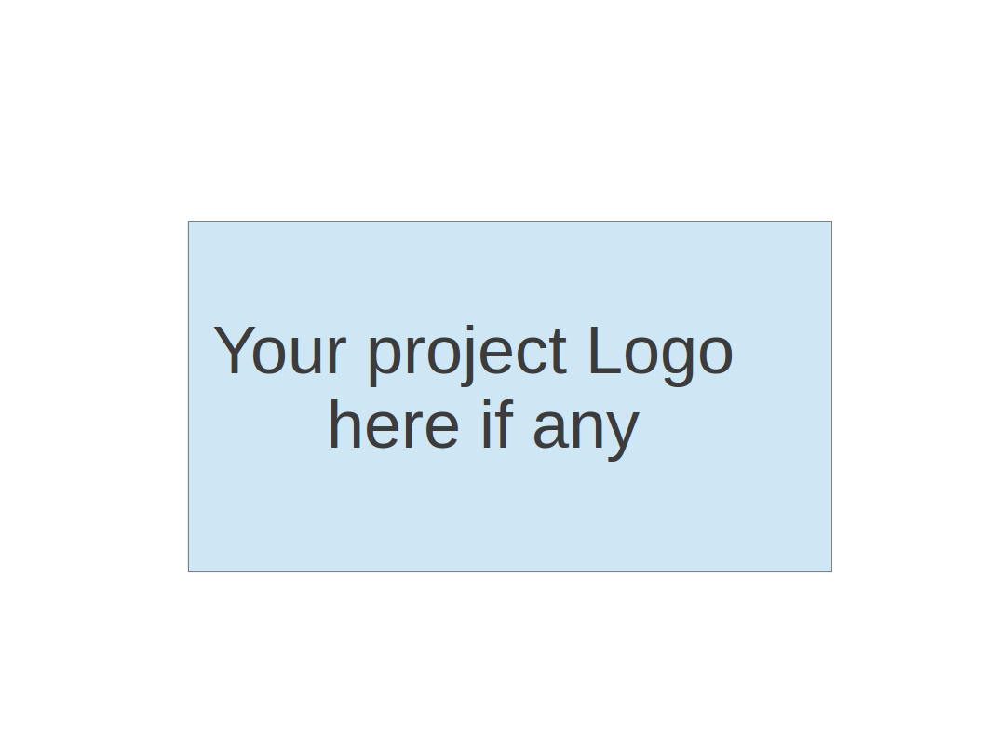

**Team 5 - Cafi**

**Project Proposal and Planning**

| **Team Member** | **Role(s)** | **Signature** | **Date** |
| --- | --- | --- | --- |
|  |  |  |  |
| **Matthew Kluska** | Overall team leader | *Matthew Kluska* | 09/10/2022 |
| **Aidan Chang** | Design and Implementation leader | *Aidan Chang* | 09/10/2022 |
| **Derric Syme** | Configuration leader | *Derric Syme* | 09/10/2022 |
| **Brendan Truong** | QA leader | *Brendan Truong* | 09/10/2022 |
| **Patounezambo OUEDRAOGO** | Requirement leader | ***Patounezambo*** | 09/10/2022 |
| **Zengrui Luo** | Security leader | *Zengrui Luo* | 09/10/2022 |
|  |  |  |  |
|  |  |  |  |

**Revision history**

| **Version** | **Author** | **Date** | **Change** |
| --- | --- | --- | --- |
| 1 | Patounezambo OUEDRAOGO | 9/12/2022 | - |
|  |  |  |  |
|  |  |  |  |
|  |  |  |  |

Overview

Related Work

Proposed High level Requirements

Management Plan

Objectives and Priorities

Risk Management (need to be updated constantly)

Timeline (need to be updated at the end of each iteration)

Configuration Management Plan

Tools

Deployment Plan if applicable

Quality Assurance Plan

Metrics

Code Review Process

Testing

Defect Management

References

Glossary

# Overview

(Please give an overview of your project. It should include the motivation, the purpose and the potential users of the proposed software system, the basic functionality of the proposed software system and the possible technology stack to be used. )

* Our project is about the creation of an image recognition application leveraging technologies such as PyTorch for a ML framework, and providing user experience through a Flask web framework. Specifically, we are working on a cat identification web application called **Cafi,** standing for **Cat Finder**.
* Computers’ ability to accurately recognize images will play a key role in many sectors of innovation. For instance, many tech companies are determined to hasten the day when self-driving cars are ubiquitous. This will only be possible if cars can avoid being involved in accidents by accurately identifying images of people, animals and objects such as other cars, etc. Similarly the vast amount of funds that are being spent on robot development with the aim of automating many tasks in various fields such as business, defense, etc., will only be worth it if those robots can successfully make “intelligent” decisions based on accurate recognition of various forms of images.
* Potential users of our cat image recognition software could use it to perform image content search, search cat videos labeled with a cat image for example, etc. Additionally, other developers can also use our code and expand its use case to include more images for diverse purposes. For example, our framework can be repurposed by other developers to quickly plug in their ML models and provide a front end framework for users.
* We plan to use Python libraries in our tech stack. Flask to create a front end, and Pytorch to utilize pretrained models for identifying Cats. Git and Github will be used for version control. Potentially, AWS services such as EC2, Cloudwatch, and Elastic Beanstalk will be used to deploy our application.

# Related Work

(Please describe any similar software systems that you have found through the online research, and the differences between your software and those software systems.)

* **Amazon Rekognition** (<https://aws.amazon.com/rekognition/> )

Amazon Rekognition allows for easily adding image and video analysis to applications. It has the ability to identify the “objects, people, text, scenes, and activities, or any inappropriate content from an image or video”. Our program on the other hand will for now be limited to identifying cats with the potential for other elements in the future when expanded.

* **Syte**

Syte is described as being the “world’s first product discovery platform”. Syte leverages AI to revolutionize ecommerce by allowing retail businesses and brands to seamlessly connect with their products, thus driving conversion rates up in sales([www.syte.ai](http://www.syte.ai)). Our software is similar to Syte but it differs in that it is a mini version of it.

# Proposed High level Requirements

**Functional Requirements**  
(For each functional requirement, please give a feature title and a brief description using the following format: As (a role), I want to (action), so that (value).)

* + 1. Essential Features (the core features that you definitely need to finish):

(For each essential features, please give a rough estimation in terms of person hours or an range of person hours)

* + 1. Desirable Features (the nice features that you really want to have too):
    2. Optional Features (additional cool features that you want to have if there is time):
    3. Existing Features (delete this item if your project starts from scratch):

1. **Front-end website**
2. Essential Features:
   1. The website consists of two tabs:
      1. Main Tab: Tab where an end user can upload and submit an image from their local machine. Along with radio buttons on the correct category of the image (cat or not cat). Once submitted, after a potential loading screen, the user will then be alerted on the ML model’s results and statistics comparing it against the radio button selection.
      2. History Tab: Tab where we will display historic submission events which consist of reduced size image, the prediction, and background color of green or red correlating to a correct or incorrect prediction.
3. Desirable Features:
   1. The website can access the webcam to capture live photos.
   2. User account with SSO, MFA, and other security features.
   3. Filters for searching and historical management in the history tab.
4. Optional Features:
   1. Build the app on phone applications such as Android and ios to access phone’s cameras
   2. Have the WebUI be mobile browser friendly and retain a good experience cross platform.
   3. The ability to upload and predict on a directory of images or multiple images.
5. **ML Algorithm**
6. Essential Features:
   1. We will be utilizing a pre-trained cat detection model implemented by pytorch.
   2. Goal is to achieve 95% accuracy.
   3. Returns confidence rate alone with predictions.
7. Desirable Features:
8. Enable a flexible framework where we can easily substitute the ML model and UI text to accommodate for other identifiers (interchangeably identify other animals or objects)
   1. This could be configurable through a file configuration or by highlighting key directions to fork and replace essential modules.
9. **Nonfunctional Requirements**

* **Usability requirement** User-friendly User Interface
* **Reliability requirement** The application needs to be reliable at >95%
* **Compatibility requirement**The application should function with most browsers and most image types(e.g .jpg, png, PNG, JPEG, PPM, GIF, TIFF, and BMP etc.)
* **Responsiveness requirement**Responsive UI (That is, the web UI should be responsive and intuitive to user interaction)
* **Security requirement**The application should be secure especially using back-end security measures such that no unauthorized data type can be used as input. Similarly, unauthorized users should not have access to the service.
* **Delivery Requirement**The software should be ready for use and delivered by the deadline
* **Implementation Requirement**The software should be be written in Python: Flask, Pytorch

# Management Plan

## Objectives and Priorities

(Please describe your project objectives with highest priority first. Project Goals can include but not limited to complete all proposed (essential) features, deploy the software successfully, the software has no known bugs, maintain high quality, etc )

I. Aligning on the problem statement, business objectives and documentation responsibilities for all leaders.

II. Aligning on the tech stack.

III. Aligning on the technical architecture.

IV. Distilling high level requirements.

1. Objectives and Priorities
   1. Identify the ML model and test it in local environment
   2. Establish APIs and set up back-end server
   3. Establish front-end architecture and connects the ML API
   4. Fine tune the system and ensure highest reliability is achieved

## Risk Management (need to be updated constantly)

(Please write a summary paragraph about the main risks your group identified and how you plan to manage these risks. Then use the separate google sheet for detailed risk management. The template is provided in the same folder with this file. Please provide the link to the sheet.)

1. Risk Management
   1. The main risks in Iteration 0 are:
      1. Configure our environment across the board to run ML libraries.
      2. Decide the best ML pre-trained model that we want to implement
      3. Decide the best back-end server.
      4. Decide the best connection (API) we want to use.
   2. [**Risk Management Sheet Link:**](https://docs.google.com/spreadsheets/d/1pPxfI9J5PbmwEcyH4_ezYLgKswIMzvFdm_CG_4NBFPs/edit#gid=0)
2. Timeline (this section should be filled in iteration 0 and updated at the end of each later iteration)

| Iteration | Functional Requirements(Essential/Disable/Option) | Tasks (Cross requirements tasks) | Estimated/real person hours |
| --- | --- | --- | --- |
| 1 | Main tab | Implement an interface for image submission | 35 hours |
| 2 | History tab | To be expressed in future iterations | 35 hours |
| 3 | ML algorithm | Implement pre-trained model | 40 hours |

# **Configuration Management Plan** -

1. **Tools**

(In this project, we will use Git and Github as the version control tools. Please also specify any other tools to be used, e.g. IDE tools, CI/CD tools, container tools, SAST or DAST tools, and any other DevOps tools)

For version control, our team will be using Git and Github.

For IDE tools, our team will flexibly use either a Python IDE (i.e. PyCharm, Spyder) or a text editor (Visual Studio Code) of choice depending on each member’s personal experience and preference.

For CI/CD automation, our team is looking to use Github Actions to automate testing, but will consider other alternatives in the coming weeks.

For DevOps, our team will be using Pivotal Tracker to manage an Agile methodology project management approach.

1. **Code Commit Guideline and Git Branching Strategy**

Our branching strategy of choice is Github Flow, as it is ideal for our use case. As this project spans only six weeks and is rather small in terms of development team size, Github Flow lets us simply create feature branches in quick succession as we develop our application, directly merge it into the main branch, supply continuous CI/CD, and have our code in a constant state.

A feature branch should be created for each new feature. A pull request to merge this feature branch into main should be opened when the feature is complete. At least one team member should approve a pull request before it is merged, but the entire time is encouraged to review for major changes.

A pull request template will be created to add documented descriptions, testing notes, and checklist best practices.

Each commit should be reviewed by 2 team members prior to merging. When impending deadlines demand it, a single team member may review and approve a merge request, but this should be avoided.

## Deployment Plan if applicable

Our minimal goal would be to develop our web framework with Flask and have it functional, fully tested, and performing to standard locally.

Our stretch goal will be to use AWS Elastic Beanstalk to deploy our application onto an AWS EC2 instance, set up security groups for inbound traffic, configure load balancers to distribute requests, store our code on AWS S3, and set up CloudWatch alarms to monitor the load of the instance, and configure an auto scaling group in case of instance failure/termination.

# **Quality Assurance Plan** -

## Metrics

| Metric Name | Description |
| --- | --- |
| # of Test Cases | The amount of test cases. |
| Test Case Pass Rate | The percentage of test cases that pass. |
| Confidence Rate | How confident (%) the algorithm is that the presented image contains a cat. |
| Accuracy | How accurate(%) the algorithm is at predicting cats over a dataset of animals |
| Test Code Coverage | The percentage of our code that our test cases cover. Ideally we would have tests that check all our methods. |
| Cost | The amount of person hours invested by the team. |
| # of User Stories completed | The amount of user stories completed. |

* 1. **Coding Standard**

Our code will follow the PEP 8 coding convention. (https://peps.python.org/pep-0008/)

## Code Review Process

Pull requests will be used for the code review. A pull request must be opened and will be required to merge changes to our main branch. At Least one peer must review a pull request before it can be merged (enforced by the repository setting). All team members will be involved in the code review process.

Pull requests will be templated with sections for description, type of change, any testing notes, and a checklist of coding practices to review. This will serve to help in documentation of the project along with enforcing best practices.

## Testing

A collection of unit tests can be integrated for feature testing.

The QA leader will provide special focus in integration testing of front end UI and the backend along with performance testing of the end to end application from a user experience perspective.

The test suite can be automated through Github Actions, to run on each Pull Request and ensure both code coverage and pass percentages are met.

## Defect Management

The team will use GitHub issues for defect management. Issues will be raised whenever a team member discovers a defect or potential enhancement in their work. This may occur during the development of a feature or during testing. If the issue is minor, it will be raised and left until there is capacity to address the issue, or until the next iteration. If the issue is major and requires immediate attention, it will be taken on by the team based on capacity.

Types of defects may include arithmetic defects in our ML model, logic defects in our code, user interface defects in our front end UI, or performance defects.

The QA leader will be in charge of reviewing any issues, measuring urgency, and solutioning.

# References

(For more details, please refer to the encounter example in the book or the software version of the documents posted on blackboard. )

Mishra, Abhishek. “Machine Learning in the AWS Cloud: Add Intelligence to Applications with Amazon Sagemaker and Amazon Rekognition.” *Amazon*, John Wiley & Sons, 2019, https://aws.amazon.com/rekognition/.

“The World's First Product Discovery Platform.” *Syte*, 4 May 2022, https://www.syte.ai/.

“GitHub Flow.” *GitHub Docs*, https://docs.github.com/en/get-started/quickstart/github-flow.

“Python Enhancement Proposals.” *PEP 8 – Style Guide for Python Code*, https://peps.python.org/pep-0008/.

# Glossary

(Any acronym used in the document should be explained here)

Cafi: Cat Finder

AWS: Amazon Web Services

QA: Quality Assurance

ML: Machine Learning

UI: User Interface

CI/CD: Continuous Integration/Continuous Deployment

IDE: Integrated Development Environment